(date)

(Name of employer and address)

By email (email address)
Dear ______
COVID 19 VACCINATION
Thank you for your letter dated_____in response to my original letter dated _______ outlining my concerns regarding the experimental covid 19 injection. Both pieces of correspondence are attached to this email for reference should either of us need to obtain formal legal advice or representation.
As outlined in my original letter, the covid-19 injection has not had full TGA approval, nor any full regulatory approval globally. The long- term safety risks are unknown, and this experimental injection is still in a live clinical trial as confirmed by Federal Health Minister Greg Hunt, such clinical trial ending in April 2023. In my letter, I asked for the legal basis you are using to mandate that someone can be forced into a medical experiment without their ability to say no. I note your formal written response has ignored my query to outline how the proposed mandate is at all lawful.
You are proposing to mandate this experimental injection even though it has not had thorough and long-term safety testing and has risks of injury and death (such injuries and deaths already documented with the TGA). If I decide take it and has an adverse reaction or worse I die, then I wanted to make you aware that employers do not escape liability for personal injury compensation For example, the NSW Government recently introduced the Public Health Amendment (Vaccination Compensation) Bill 2021 that will make employers liable for any injuries or adverse reactions to the experimental vaccine. https://www.parliament.nsw.gov.au/bill/files/3835/First%20Print.pdf
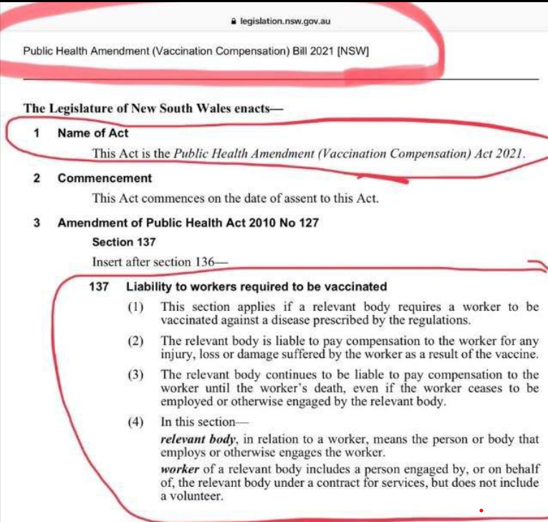
The addition of section 137 outlines the liability to workers required to be vaccinated.
In Victoria where an employer’s direction to employees result in the employee’s injury or death, it is now considered workplace manslaughter, and criminal penalties apply in addition to financial penalties. Please see link here: https://www.worksafe.vic.gov.au/victorias-new-workplace-manslaughter-offences
The implications of mandating this experimental injection are significant in terms of the potential to cause injury or death to employees and the increased liability to employers. Safe Work Australia (SWA) announced that it is unlikely that requiring workers to be vaccinated for COVID-19 will be a reasonably practicable control measure for the purposes of workplace health and safety legislation. At present, there is also no express guidance from the courts or the Fair Work Commission (FWC) on whether requiring employees to be vaccinated is a lawful and reasonable direction. Therefore, your proposed mandate is not confirmed by the courts to be a lawful and reasonable one.
In the Australian Government’s Immunisation Handbook under Section 2.1.3 Valid Consent, it states that for consent to be legally valid “It must be given voluntarily in the absence of undue pressure, coercion or manipulation.”¹ Your correspondence dated ________ says that any employee that has not had the first dose of the experimental vaccine by ___2021, will not be permitted to work. This position is exerting economic duress upon me, by forcing me to choose between participating in a clinical trial (experiment), or to lose my job. This is coercion and not permitted under national employment laws. In addition, making a threat to someone (e.g. the loss of a job) unless the person takes part in a medical experiment (which would otherwise entitle a person to give informed consent) amounts to a criminal offence and could result in the person making this threat being charged with that criminal offence.
I am very concerned about the side effects of this experimental injection which contains Graphene Oxide amongst many other toxic ingredients. Graphene Oxide is an oxygen sponge which deprives the body of necessary oxygen and causes many complications, including but not limited to anaphylactic shock, toxic blood clotting, fatal lung paralysis, mitochondrial cancer, and endothelial cancer. The risk of severe injury or death is very high.
Further, I should also be given the opportunity to discuss my health and any proposed medical treatment with my doctor. What medical treatment and medical advice I receive and all my medical information is private and confidential.
I hope that the points raised above, and in my letter dated ______, will form part of your policy to ensure informed consent, with the ability for any employee to say no to this experimental injection. If not, then I await your written response to all questions in my original letter.

Kind regards,

https://immunisationhandbook.health.gov.au/vaccination-procedures/preparing-for-vaccination
https://www.vaccinedeaths.com/2021-08-15-graphene-oxide-in-coronavirus-vaccines-linked-to-death.html

